  
    - December 11, 2019
  Pennington Wine and Jazz Events
  Pennington is the home to a series of music and wine tasting events at the Hopewell Valley Vineyards during the last week of December. The events taking place at Hopewell should be exactly what you were looking for. Hopewell is an award winning vineyard, having won the New Jersey Governors Cup for their Chambourcin previously.
  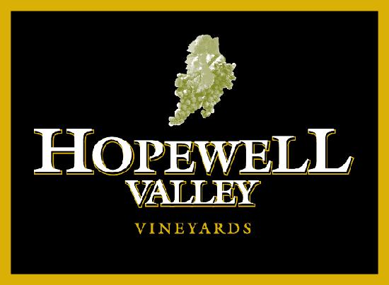 best taste ever
  we provide state parks, historical sites and recreational activities (e.g., fishing, boating, skiing).
  During the week of december 23rd through december 29th, we have a week-long festival celebrating our wines and local jazz music.
  the event is well organized and provide an excellent opportunity to sample the variety of wines available at the vineyard, and enjoy listening to the best of local jazz.
  we are the champions of wines and jazz music.
  n
  we are looking forward for your visit
  Department of State
  Division of Travel and Tourism
  225W. State Street
  Trenton, New Jersey 08608
  (609) 292-2470
  www.pennington.com
  Website
  Dates and Times

